Project 1

By Emmanuel Nimo, Gloria Sekyere, Raymond Saaka, Samuel Bunyan

Software Engineering

Ashesi University

# **Abstract**

In recent times, there has been a huge growth in home security devices, but most of these devices are expensive to acquire. This project was undertaken to help provide an affordable solution model to overcome security breaches in households. Consequently, an investigation was carried out to discover the existing technologies to provide a suitable solution to the security challenges faced in Ghana. Since the system developed in this project was a prototype, there is plenty of room to develop the system further to make it an efficient system to deploy in households. This implementation did not consider the user entering a personalized code into the system to help gain access to the household. As such, when the system is on, any obstruction that comes near the system is regarded as an intruder into the system since no differentiating mechanism was implemented. This aspect can be explored further in the future advancement of this system. After analyzing the implemented system, it was obtained that the response time of the system is 5 seconds. This response time indicates the difference in time from when an intrusion occurs when the homeowner receives an SMS alert.

**Table of Contents**

**Abstract** 2

**Project Details** 4

**Project Title:** 4

**Team Name:** 4

**Team Members** 4

**Project Description** 4

**Software Engineering Methodology** 5

**Justification/Motivation** 5

**Software Engineering Cycle** 7

**Requirements Specification** 7

Functional requirements: 7

Non-functional requirements 7

**Analysis and Design** 8

Use Case Diagram 8

Activity Diagram 10

Sequence Diagram 11

Analysis 11

**Implementation** 12

**Verification & Validation** 15

**Product Deployment** 15

**Future Works** 15

# **Project Details**

## **Project Title:**

Development of an affordable security alarm system.

## **Team Name:**

GRES Engineers

## **Team Members**

* Emmanuel Nimo
* Gloria Sekyere
* Raymond Saaka
* Samuel Bunyan

## **Project Description**

The evolution of technology in recent years has led to the enhancement of our everyday activities, especially for those in the upper class of society. Despite the incredible gains made in technology all over the world, patronage of technology to improve our lifestyle has been left primarily to those that can afford it, depriving many people from lower backgrounds of access to certain technology. One typical example of technology that is absent in many homes in Ghana, is a security alarm system. In many homes, in spite of frequent occurrences of theft cases, the benefits from installing a security alarm system has still not been seen as worth its cost.

To tackle this problem, this project aims to develop an affordable security system for households by applying the key software engineering principles. Since safety and security are essential aspects of living, this project aims to provide a comfortable secure household. With the development of this security alarm system, users would be alerted when an unauthorized entry is attempted in any household. This would prepare users adequately for any intrusion into their homes. The security alarm system would be developed using a microcontroller, a breadboard, an ultrasonic sensor for motion detection, a buzzer for alarm and a GSM alert. The entire circuity will rely on Arduino software to operate.

## **Software Engineering Methodology**

The project shall employ the plan-driven development approach in carrying out this project. With this more formal and specific development approach, all process activities are planned in advance and progress is measured against this plan. This approach would be used for this project because it is well structured and would help the team provide a realistic time schedule for the project. Moreover, it provides distinct deliverables towards detailed documentation. With our approach well aligned and planned, the team carried out its activities step by step and towards coming up with the final implementation. Trello was used to outline the activities to carry out to provide a clear approach. The diagram below shows the online software application used to manage the completion of our activities and represent a point in time during project implementation.

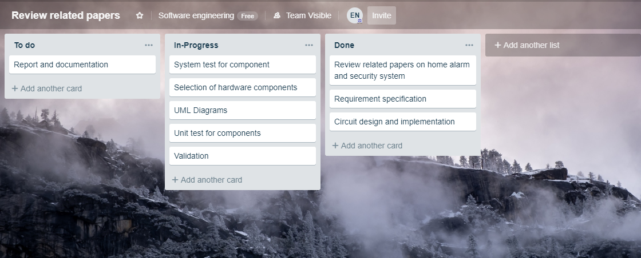

Figure 1: Flow of Activities and their status at a particular point during project implementation.

# **Justification/Motivation**

In a research conducted by Raj G. Anvekar and Dr. Rajeshwari M. Banakar, they designed a low-power, cost effective and IoT based home security system which helps in presence detection, identification and authentication of strangers [1]. The article highlights the model driven development process for home security systems. This was done by using a customer end technology such as Telegram to transmit information through layers of IoT architecture. The implementation was carried out by using raspberry pi microcontroller and other peripheral components such as PIR sensors, electric door sensor etc. The sensor data collected were sent to a web application via a GSM module for users to access the information on the status of the security system.

However, the following challenges were discovered in several research papers we reviewed.

1. First, the network infrastructure needs high quality data to be transmitted meaning it needs a stable wireless network connectivity.
2. Again, the Internet needs to also be stable and available for easy connections between end-devices. This will enable a constant flow of data exchange between the devices.
3. Another challenge was finding the most affordable and energy-efficient device to be used for the security system. Some devices have advantage in some areas than others, therefore trying to get one that best suits the function is quite challenging [2]
4. Most of the data were sent to a web application to be viewed by users. A few of such projects had SMS alert to prompt users about intrusion or theft cases.

Considering the increasing rate of theft cases or home intrusions in several poor communities, we would like to embark on this project to experiment the viability and progress of home security. We will be using ultrasonic sensor detection and SMS alert to prompt home owners about theft cases or home intrusion. Again, this project is pursued because it will significantly attach a greater credibility to our practical knowledge as software engineers. It will further raise awareness for the prevention and mitigation of theft cases and home intrusion.

# **Software Engineering Cycle**

## **Requirements Specification**

In order to delve further into the problem we wanted to tackle, the team carried out some brief research to place the problem into context. Consequently, by interviewing a few members of the Ashesi Community, the team gathered that although security breaches are common in the country, it seems too difficult to deploy from a distance. Investigating further, the team discovered that many wanted a system that would not only ring loudly to drive thieves away, but would rather have a means in which they were instantly informed if someone breaks into their house should they be away from home. Based on all the insights gained from interviewing, the team put together the functional requirements and non-functional requirements of the alarm system to be implemented.

### Functional requirements:

* The user should be able to specify the range for the sensor
* The user should be able to reset the system in the case of an error
* The alarm should sound anytime the specified sensor range is exceeded
* Once sensor range is exceeded the GSM module should send an SMS alert to the user informing the user of the intrusion
* Green LED should be on when system is at rest, turn on red LED when there is an intrusion

### Non-functional requirements

* *Performance:* Per the measurements after implementation SMS alerts take 5 seconds to reach the home owner after an intruder has been detected.
* *Reliability:* The system always shows the expected LED indicator when an object is close to the ultrasonic sensor
* *Maintainability:* The reset button allows for the home owner to reset the system to default settings in the event it is not working as expected.

## **Analysis and Design**

Before delving into the development of the alarm system, the team presented high-level representation of the proposed system to guide the construction of the system. This was achieved by constructing three UML diagrams after careful analysis of the system to be implemented. The three diagrams are presented below and were designed using Creately; an online platform:

### Use Case Diagram

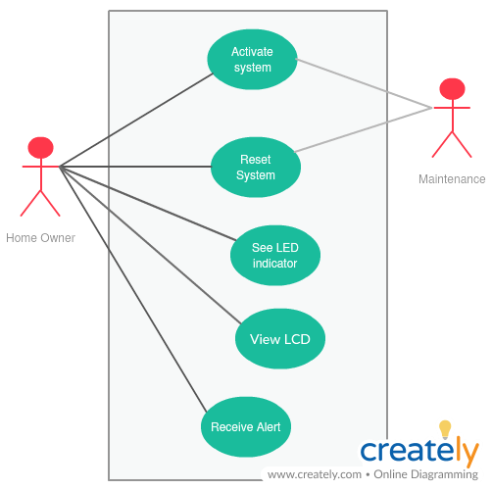The diagram below represents the use case diagram for the constructed alarm system. The use case diagram was constructed by first identifying the actors; Home Owner and Maintenance. From this identification, the actions the actors would be expected to perform in the system was then used to complete the construction of the use case diagram. Activate System is performed by connecting the alarm system to a power source, and can also be carried out by the maintenance team. Reset system is used to refresh the system in case it is not working as expected and can be carried out by both the home owner and the maintenance team. “See LED indicator” and “View LCD Display” is performed by the home owner in the system and is used to showcase the status of the alarm system, indicating whether an intruder is present or not. “Receive Alert” is an action enabled when an intruder breaks into the system alerting the home owner of his/her presence.

Figure 2: Use Case Diagram for the Burglar Alarm System

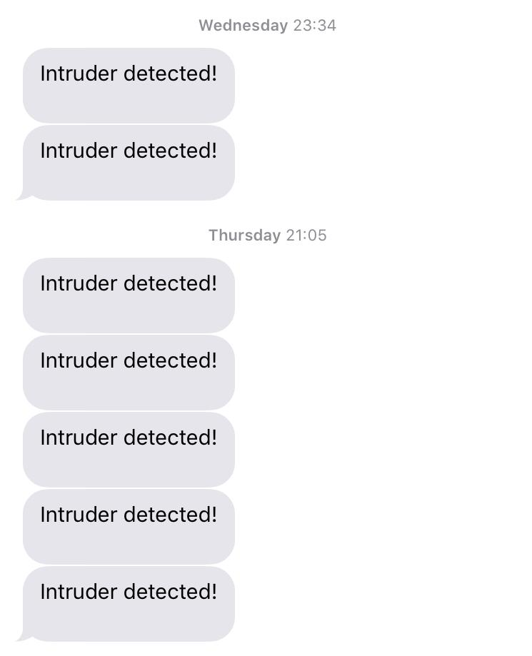

Figure 3. A screenshot of the SMS alert received by the user upon detection of an intruder.

### Activity Diagram

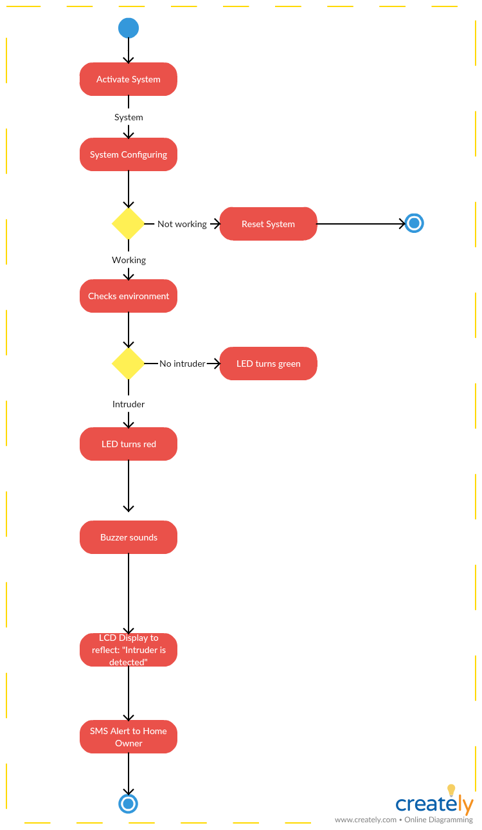 By considering the flow of actions of the burglar alarm system to be designed, an activity diagram was constructed.

Figure 4: Activity diagram for the Burglar Alarm System

### Sequence Diagram

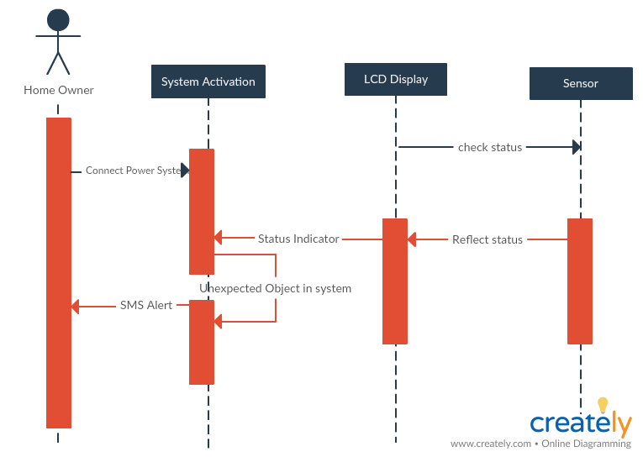 The interactions between various components of the alarm system is depicted in the sequence diagram below.

Figure 5: Sequence Diagram for the Burglar Alarm System

### Analysis

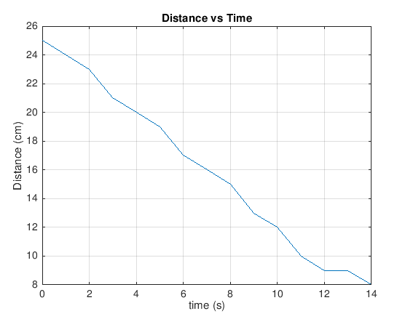In the analysis, as time increases, the distance measured decreases because the obstruction gets closer to the ultrasonic sensor. At distance of 10cm, it was observed that the microcontroller commands the GSM to issue a string of texts as an alert to the user’s mobile contact. It took an average of 5 seconds for the text to reach the target destination.

Figure 6: Distance vs Time Graph

## **Implementation**

In developing the burglar alarm system, the system was modeled by constructing a circuit to demonstrate the working principle of the system. Accordingly, per the system modeled, when an object moves within the environment of the circuit, the system rings, alerting the user in the process. A text message is then sent to the user, informing the user of the intruder in the system. This is used to simulate the operational mechanism of the alarm system when someone breaks into the environment in which it is deployed.

The main components that make up the alarm system circuit that was deployed is as follows:

* Ultrasonic Sensor – To detect when an object falls within the range (representing the intruder into the system)
* Arduino Uno - Used to control how the system should react when an intruder into the system is detected
* GSM Module –Used to send SMS messages to alert the user that an intruder has entered the system
* Buzzer – Used to alert the user that someone has entered the system
* LED – Used to indicate whether the system is free from an intruder or not (red – intruder present, green – no intruder present)
* Button – Used to reset the system in case it is not functioning properly
* LCD Display – Used to indicate status of the system.

The diagram below represents the circuit diagram of the system. This was constructed using Proteus, a software for designing circuit schematics.

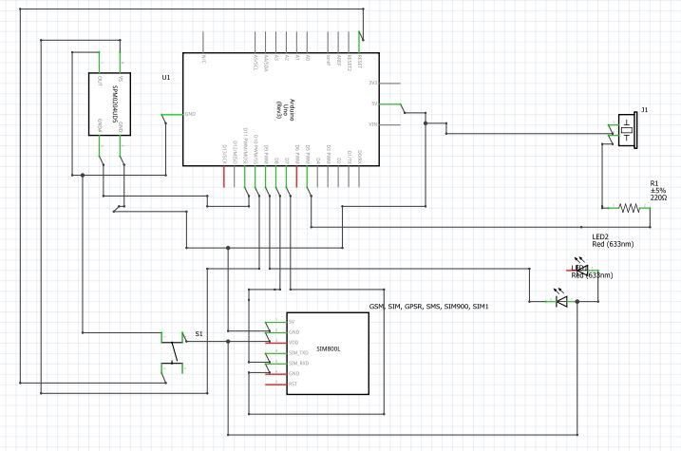

Figure 7: Alarm System Circuit

Following the design of the circuit using Proteus, the system was implemented on a breadboard using the appropriate components required. The circuit is shown in fig. 6 and fig. 7 accordingly.

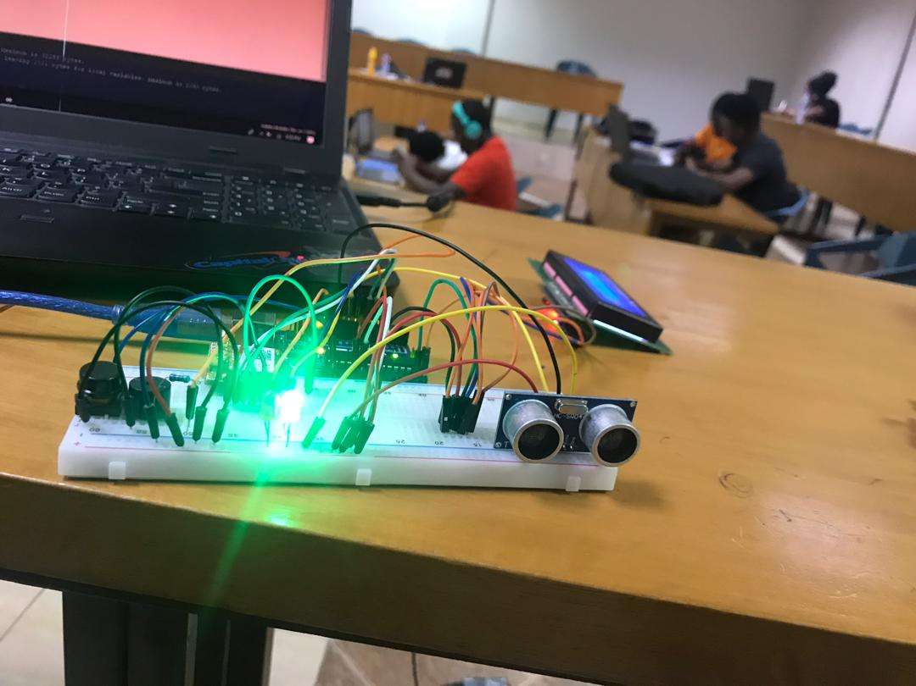

Figure 8: Constructed circuit modelling an alarm system (LED turns green)

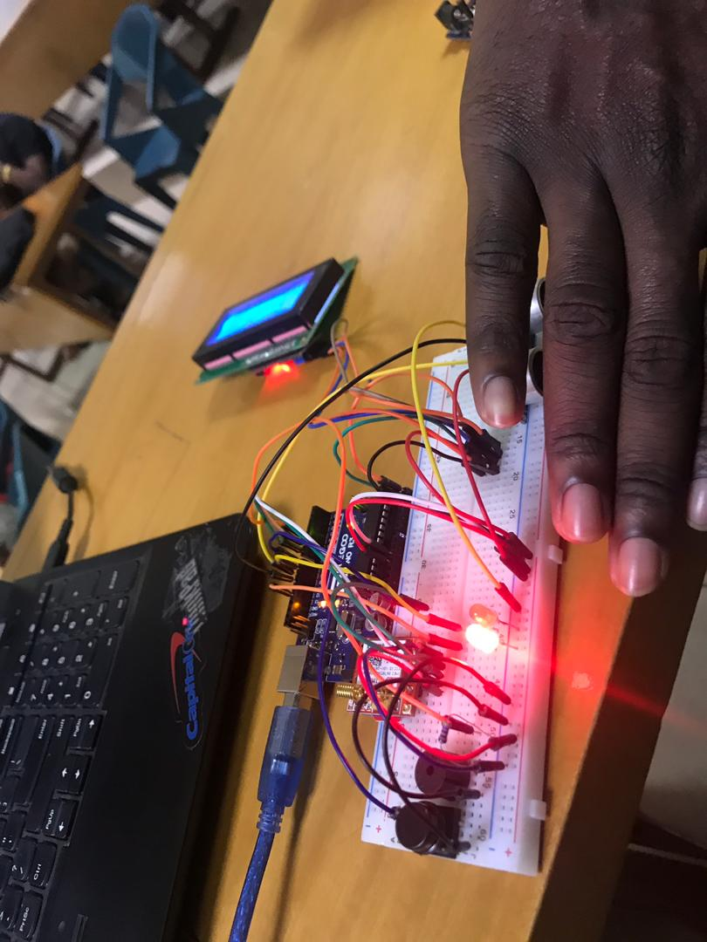In fig. 6 above, as indicated by the green light, there is no intruder in the system. This is achieved by the ultrasonic sensor which is used to detect whether there is something close to it. Since there is no object close to it the LED turns green.

Figure 9: Constructed circuit modelling an alarm system (LED turns red)

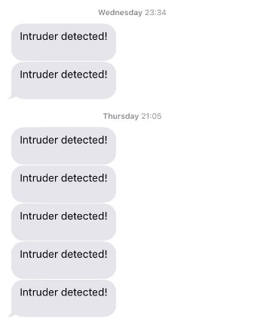From fig. 7, the reaction of the system when an object is within the range is depicted by the LED turning red. This is used to model the existence of an intruder in the system. While the LED turns red (indicating the existence of an intruder), an SMS message is simultaneously sent to the user (shown in fig. 8) to inform him of the intrusion into his or her home. This is particularly essential because it gives the user a prompt alert to enable him to think about the suitable action to take.

Figure 10: SMS Alert to user

## **Verification & Validation**

The alarm system designed for this project only takes one input which is the reset button and is used to handle errors in the system. It achieves this handling of errors by restarting the system. The serial monitor is also used to translate what the system is producing into a string to be presented to the user of the alarm system.

## **Product Deployment**

Using the Arduino code and libraries, the application layer allows the written program to be deployed onto the microcontroller. The microcontroller as a core receives the instructions through the physical layer (USB cable). The instructions are therefore distributed to the various General-Purpose Input Output (GPIO) pins or ports connected to the ultrasonic, and other peripheral components such the GSM, buzzer, etc. The sensor report changes in the environment to the microcontroller in the form of analog signals (volts) which is digitized through sampling. The GSM uses AT commands and an Adafruit-Fona library to send text alerts to users. The code or the program downloaded unto the microcontroller or Arduino Uno is stored in the Flash memory and stays there until is overwritten by a new sketch of code.

## **Future Works**

For future work, further design can be undertaken to reduce the wires involved in the circuitry on the prototype. The reliability of the system can be improved by the use of more powerful sensors. Additional features can also be added to improve the functionality of the system. Facial recognition, voice recognition and fingerprint recognition are all security features that can be added or explored separately in future.

# Reference

[1] G. Anvekar and R. M. Banakar, "IoT application development: Home security system," 2017 *IEEE Technological Innovations in ICT for Agriculture and Rural Development (TIAR),* Chennai, 2017, pp. 68-72. doi: 10.1109/TIAR.2017.8273688

[2] Home automation and smart home security. *IFSEC.* 2019. Retrieved from <https://www.ifsecglobal.com/home-automation-and-smart-home-security/>

# Appendix

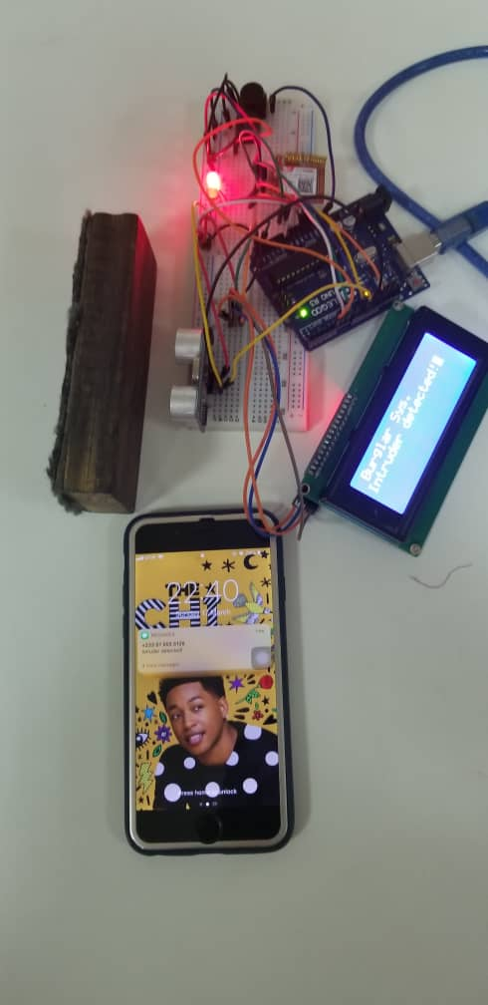 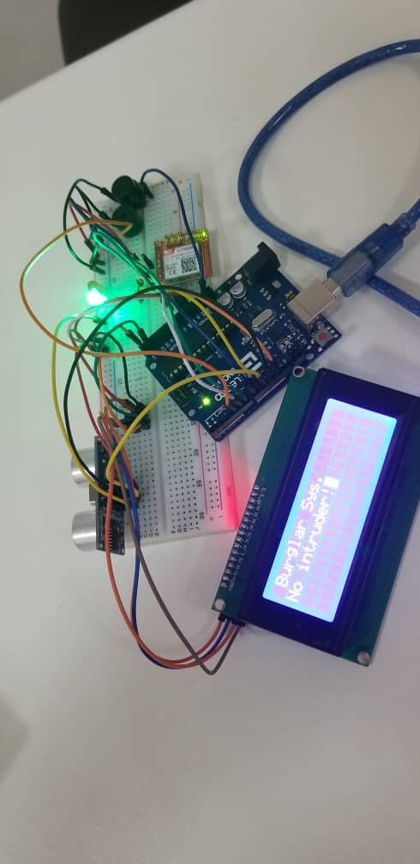

Figure 11. A picture of the system in operation when obstruction detected (left) and the absence of obstruction (right).

Android code:

<https://github.com/Nimoslaw20/SE-2019-Project-1/blob/master/burglarmlcd16/burglarmlcd16.ino>